12 Port 1U 10-inch CAT6 UTP SOHO UTP PATCH PANEL (PPAN-12-10-C6)

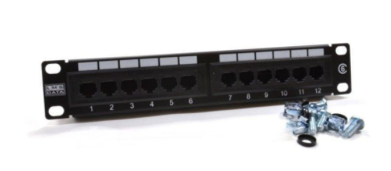

Description:
The LMS Data PPAN-12-10-C6 is 12 Port certified CAT6 UTP Patch Panel which is
designed as a SOHO (small office home office) 10-inch design. Being compact its design to fit in a range of 10-inch data cabinets found in homes and small offices.
Fully Gigabit Ethernet certified means its ideal for running legacy and advanced networking protocols to Gigabit Switches up up to 1000Mbps. Also ideal for telecom, VoIP, CCTV-IP and other Ethernet based standards.
Long-life, nickel plated female RJ45s, robust construction with colour-coded rear Krone(tm) KATT type IDC for both TIA-568A/B terminations

Upgrading your existing cat5e or even starting from scratch with a new category 6 network can be expensive. Not with LMS Data. The new LMS Data PPAN-24-C6-VLC is a low cost but importantly, high quality, 24-way cat5e UTP Patch Panel for all your structured cabling, gigabit ethernet or VoIP applications. Housed in a robust 1U high enclosure with a standard, 19-inch wide form factor means its ideal for all structured, server or broadcast type cabinets. Also incorporated is a newly developed vertical punchdown IDC which offers standard AWG copper cores a secure connection thus reducing attenuation and thus increasing signal qualities over all ethernet, VoIP and other IP networking scenarios. Part of the LMS Data 25-year warranty system*, the PPAN-24-C6-VLC is your ideal patching solution for installers,integrators and data managers.

Key Features:
- Certified CAT6 Performance for Gigabit Ethernet
- 10-inch SOHO Compact Design for 10-Inch Cabinets
- Popular Krone(tm) KATT Dual Purpose IDC Punchdown
- Removable Rear Cable Management Bar for Cable Anchoring
- Part of the Synthesis 25-Year Warranty Solution
- 24-Port, 19-inch wide category 6 patch panel
- Compact and robust 1U form-factor design
- Exceeds current category 6 performance
- TIA-EIA-568A/B2.1with Krone AT&T (KATT) IDC
- Phosphor bronze and Nickel IDC connectors
- Gold over Nickel IDC connectors RJ45 connectors
- Supports 22 to 26 AWG conductor diameters
- Port identification and labelling facility
- Bundled cage nuts for cabinet attachment

Applications:
- Office, Education and Home Structured Cabling Installs
- Ideal for Gigabit Ethernet (1000Mbps) Data Networks
- Create fault tolerant LANs by simply patching ports

Product Code:
- Part Number: PPAN-24-C6-VLC
- EAN: 8400800032171
- Weight: 1 Kg approx.

Technical Specifications:
- Port Count: 24 Ports UTP
- Dimensions:1U 19-Inch Design Format
- Conformance: TIA-EIA-568A/568-B2.1 Coded IDC
- Performance :10/100/1000Mbps Gigabit Compliance
- RJ45/IDC Connects: Nickel and Phosphor Bronze
- Port Identification; Numbered and Bespoke ID Marker
- Fixings: Supplied M6 Nuts and Bolts
* Specifications and product design are subject to change. E&OE.

